FDE AI HACKATHON 5.0
Participant Problem Statement
Four business problems, as the sponsors described them. Your task is to understand the problem, break it down to its core and propose a solution.

For Hackathon participants
Contains The situation, how the work runs today, the data supplied and the sponsor’s own words. It does not contain the analysis — that is yours to do.

Your task
- Choose a problem (or the one you are assigned). Read its section and the data supplied or Generate Synthetic data where required.
- Understand it properly: talk to the sponsor, map how the work really runs, and find where it breaks.
- Break the problem down to its core. Say what is known, what is assumed and why it keeps happening.
- Define one outcome you could measure, and design a solution for it.
- Build a working slice and show it against the data you were given.
- Show how you would prove it worked, and say honestly what you do not yet know.
- Record all of this in the Team Response Template.

Ground rules
- Use only the data supplied for the hackathon. Do not use real personal, employee, student or customer data. Create synthetic data where needed
- Time with each sponsor is short. Prepare your questions, and note what you asked and what you learned.
- Treat each description as the sponsor’s account, not as verified fact. Check it.
- Where you make an assumption, write it down and say how you would test it.

ABOUT THE MARK †
Some steps in the process descriptions are marked †. They are the organisers’ reading of how the work probably runs and have not been confirmed with the sponsor. You are expected to check them.

Problem 1 · Transfer credit evaluation
For | Boston University (BU) — Credit Evaluation and academic departments
As the sponsor submitted it | Smarter Transfer Credit Evaluation (Theme: EdTech · Student Experience · Process Automation)
Sponsor | Pavan Vangara
Time with the sponsor | Arranged through L&D.

The situation
Every year, hundreds of students transfer into universities and need their earlier coursework evaluated for credit. Boston University welcomes more than 800 transfer students a year. Each of their courses has to be matched, reviewed and posted to the student's academic record. BU itself notes that the process takes time, and longer for some students than others, because every evaluation is done carefully.
The process is thorough, but it puts a lot of the burden on students and on reviewers. Students often cannot tell what is happening while their courses sit at zero units. Many have to chase down old syllabi, and they do not know how much of their degree progress is secure until late in the process. Evaluators review syllabi one by one, which means repeated manual comparison of course descriptions, learning outcomes and credit hours.
Your challenge is to design and build a tool that makes transfer credit evaluation faster, more transparent and less stressful. It must still respect the rule that academic departments make the final decision.

Where this sits
- Business area: BU's Credit Evaluation Department and the academic departments whose evaluators review courses (the sponsor is not yet named).
- Day-to-day users: Credit Evaluation Department staff and department evaluators. Students use the status shown in MyBU Student.
- Others affected: transfer students (800+ a year), academic advisors and the financial aid team.

How the work runs today Step by step
# | What happens | Who | Tools and data
1 | Self-check. The student previews likely course equivalencies. | Student | Transferology
2 | Transcripts. After admission, the student submits official final transcripts from every college attended. | Student | Official transcripts
3 | Processing. The Credit Evaluation Department processes each course, checking it against the equivalency database. | Credit Evaluation Department | Equivalency database
4 | If the course has already been evaluated, the existing equivalency is applied and the result is a specific BU course. | Credit Evaluation Department | Equivalency database
5 | If the course has no existing match, it is listed as “maybe”. The student must send a syllabus for the department evaluators to review. | Student | Syllabus
6 | Department review. A department evaluator reviews the syllabus and decides: a BU equivalent course, elective credit that counts as units, or no credit (0 units). | Department evaluator | Syllabus; course descriptions, learning outcomes, credit hours
7 | Result. The outcome is posted in MyBU Student with a grade of “T”. Pending credit shows as zero units until a course has been evaluated. | Credit Evaluation Department | MyBU Student
Rules that apply alongside the workflow
Status display | Pending credit shows as zero units in MyBU Student until it has been evaluated.
Quarter-system courses | Credits convert at two-thirds of a semester credit (a 4-credit quarter course becomes 2.66 BU credits).
Grades | Many BU schools require a C or higher for credit. External grades do not count toward the BU GPA.
Hub units | Transfer courses do not earn BU Hub general education units.
Deadline | All credits must be transferred within one year of starting at BU.
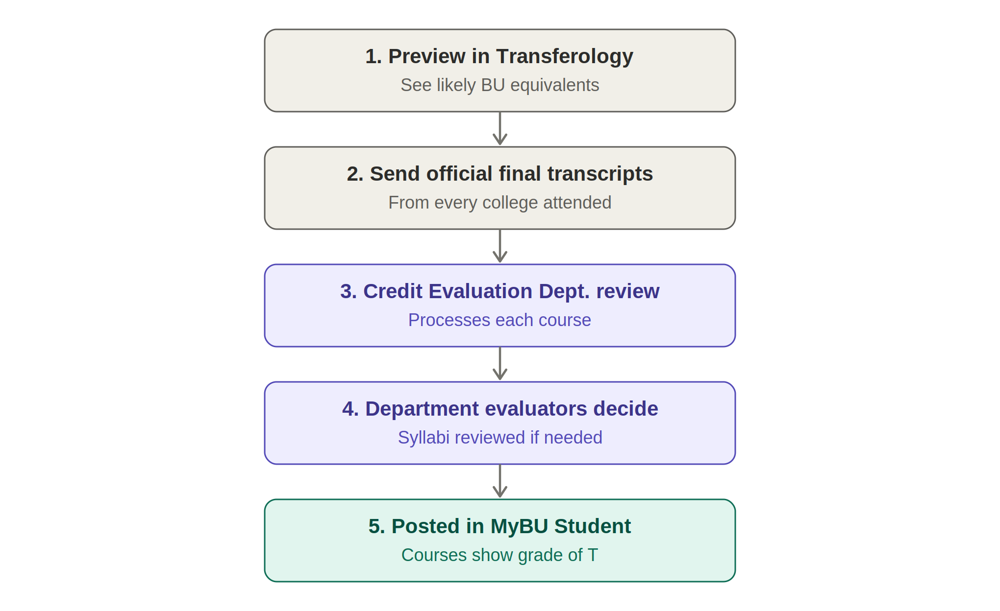
Figure 1. The current transfer credit evaluation process at Boston University
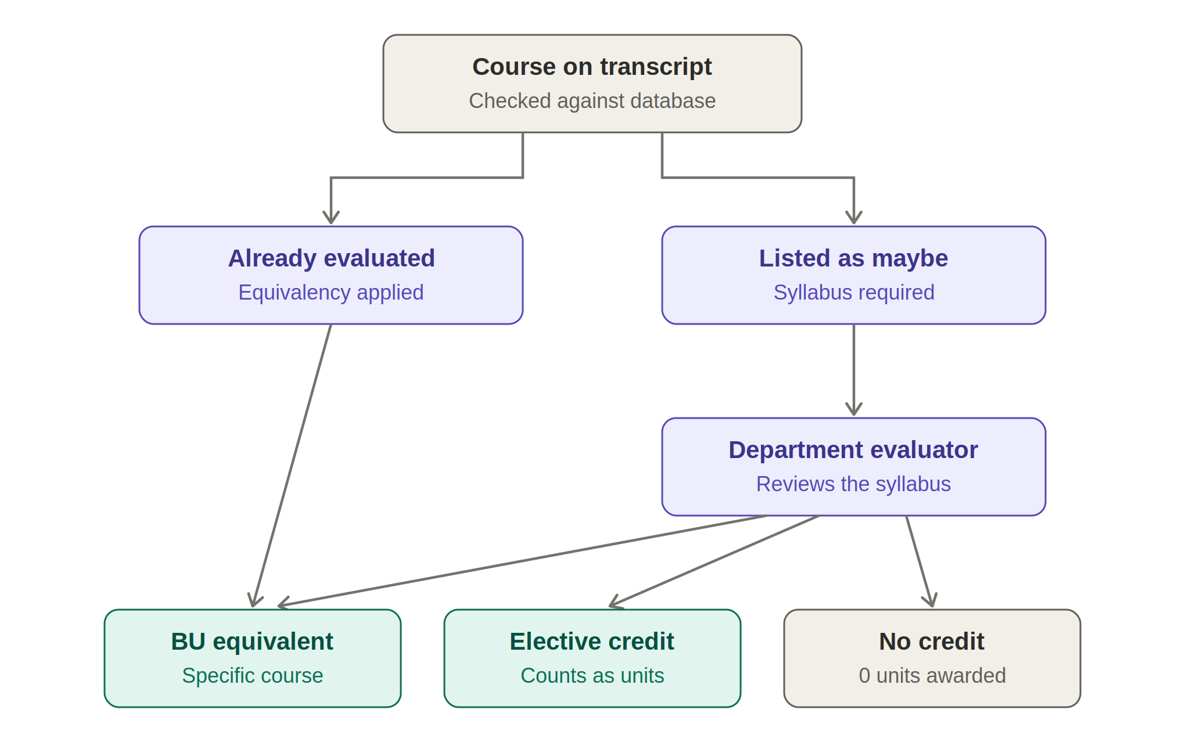
Figure 2. Decision paths for a single transfer course

Facts and numbers given
Transfer students a year | More than 800
Where a course stands before evaluation | Zero units in MyBU Student
Time limit | All credits within one year of starting at BU
Sample data planned | 3–4 transcripts; about 150 BU courses for one program; about 200 courses from two other universities; about 100 past decisions

What has been tried
Students can preview likely equivalencies in Transferology, and an equivalency database holds courses that have already been evaluated. No AI-based course matching is described in the sources; this is to be confirmed with BU.

From the problem brief
Background | Every year, hundreds of students transfer into universities and need their past coursework evaluated for credit. Boston University welcomes more than 800 transfer students annually, and each of their courses has to be matched, reviewed and posted to their academic record.
The problem for students | They often cannot tell what is happening while courses sit at zero units. Many have to chase down old syllabi, and they do not know how much of their degree progress is secure until late in the process.
The problem for evaluators | They review syllabi one by one, which means repeated manual comparison of course descriptions, learning outcomes and credit hours.
Your challenge | Design and build a tool that makes transfer credit evaluation faster, more transparent and less stressful. It should still respect the rule that academic departments make the final decision.

SUGGESTED DEMO SCENARIO
A student transfers from a community college with six courses. Three have existing equivalencies, two are listed as “maybe”, and one is from a quarter-system school. Show how your solution handles each case from upload to final posting.

Data available
Content | Sample transcripts (course, credits, grade, term); the BU course list for one program; course descriptions from two other universities (public catalogues); a few past course-match decisions. [Organisers to confirm: sample syllabi and an extract of the equivalency database.]
Format | Documents / PDFs
Size | 3–4 sample transcripts; about 150 BU courses; about 200 courses from other universities; about 100 past decisions
Available | Yes

Ground rules for this problem
- Student records are private. Use only the sample data supplied.
- Academic departments make the final decision. Your solution must leave that decision with them.

